WIKA calibration laboratories now also accredited for electrical measurement parameters

Klingenberg, April 2014.
WIKA extends its manufacturer-independent calibration service. The German National Accreditation Body (German abbreviation: DAkkS) has now certified that the company's test laboratories have the competence to also calibrate electrical measurement parameters in accordance with DIN ISO/IEC 17025:2005.

From now on, WIKA has the right to issue DKD/DAkkS certificates for DC voltage (0 V to 100 V), direct current (0 mA to 100 mA) and DC resistance (0 Ω to 10 kΩ). The scope of accreditation for the measurement parameters pressure and temperature was also extended.

The WIKA temperature laboratory is the only one so far to be accredited for testing dry-well calibrators up to -55°C. Furthermore, mechanical, direct-indicating and contact resistance thermometers can now be calibrated up to +950°C, base metal thermocouples up to -40°C.

The new services of the pressure laboratory include the DAkkS-conform calibration of differential pressure up to 10 bar, for static pressures up to 250 bar. Tests of overpressure and absolute pressure of up to 8000 bar are now also possible for on-site uses of the WIKA calibration vans.

Number of characters: 1231
Key word: DAkkS accreditations

Manufacturer:
WIKA Alexander Wiegand SE & Co. KG
Alexander-Wiegand-Straße 30
63911 Klingenberg/Germany
Tel. +49 9372 132-0
Fax: +49 9372 132-406
vertrieb@wika.com
www.wika.com

WIKA company photograph:
WIKA calibration laboratory

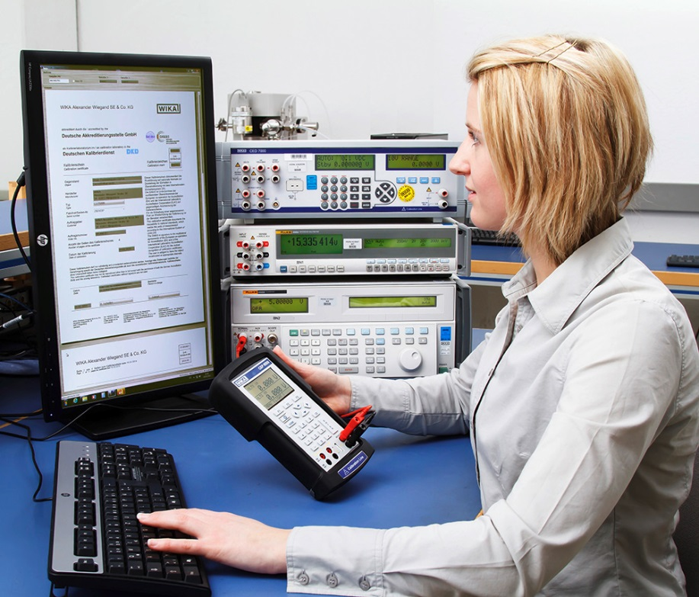

Edited by:
WIKA Alexander Wiegand SE & Co. KG
André Habel Nunes
Marketing Services
Alexander-Wiegand-Straße 30
63911 Klingenberg/Germany
Tel. +49 9372 132-8010
Fax: +49 9372 132-8008010
andre.habel-nunes@wika.com
www.wika.com

WIKA press release 06/2014

