Pressure sensor module
For industrial applications

Klingenberg, July 2021. The model MTF-1 pressure sensor module is a simple and flexible option for integrating pressure measurement into a wide variety of applications.

The pressure value is digitally processed in the module and output as a standardised digital or analogue signal. Thus, the MTF-1 module delivers precise data for applications with pressures of up to 1,000 bar. The compact module can be easily adapted to the requirements of the respective application thanks to individual configuration of the process connection and electrical connection. Adjustment of the output signal is carried out by WIKA at the factory, meaning time and cost expenditure for calibration during integration is eliminated.

The model MTF-1 pressure sensor module is designed for energy-saving operation. The digital I²C signal transmits data extremely efficiently thanks to low basic energy consumption and fast switch-on times. The energy-efficient sleep mode further reduces energy consumption. This makes the module particularly suitable for battery-operated solutions, ensures long cycles between battery changes and thus reduces maintenance costs.

Number of characters: 1.116
Key word: MTF-1

Manufacturer:
WIKA Alexander Wiegand SE & Co. KG
Alexander-Wiegand-Straße 30
63911 Klingenberg/Germany
Tel. +49 9372 132-0
Fax +49 9372 132-406
vertrieb@wika.com
www.wika.de

WIKA company photograph:
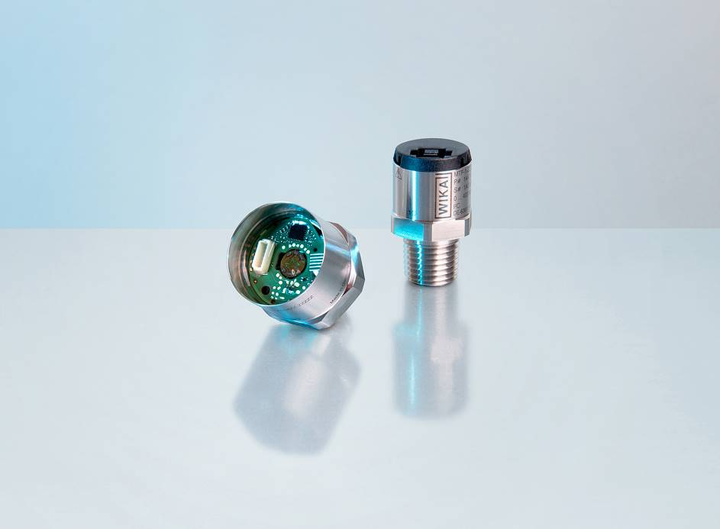
Model: MTF-1

Edited by:
WIKA Alexander Wiegand SE & Co. KG
André Habel Nunes
Marketing Services
Alexander-Wiegand-Straße 30
63911 Klingenberg/Germany
Tel. +49 9372 132-8010
Fax +49 9372 132-8008010
andre.habel-nunes@wika.com
www.wika.de

WIKA press release

