A-10 pressure transmitter
available with mbar ranges

Klingenberg, June 2016.
The A-10 pressure transmitter from WIKA is now also available with the smallest of pressure ranges from 0 … 50 mbar to
0 … 600 mbar. The wetted parts in this variant are all welded and from stainless steel.

The new mbar pressure ranges are particularly suitable for level measurements on small tanks in stationary and mobile applications. A further field of application is all types of gas measurement.

Among WIKA's measuring instruments for general industrial applications, the A-10 is a best-seller with an excellent price/performance ratio. It offers more than two million variants. Customers can choose from a wide selection of pressure ranges, process connections and output signals. A free test report provides information on the measuring points recorded during manufacture.

Number of characters: 779
Key words: A10 mbar

Manufacturer:
WIKA Alexander Wiegand SE & Co. KG
Alexander-Wiegand-Straße 30
63911 Klingenberg/Germany
Tel. +49 9372 132-0
Fax +49 9372 132-406
vertrieb@wika.com
www.wika.de

WIKA company photograph:
A-10 pressure transmitter available with mbar ranges

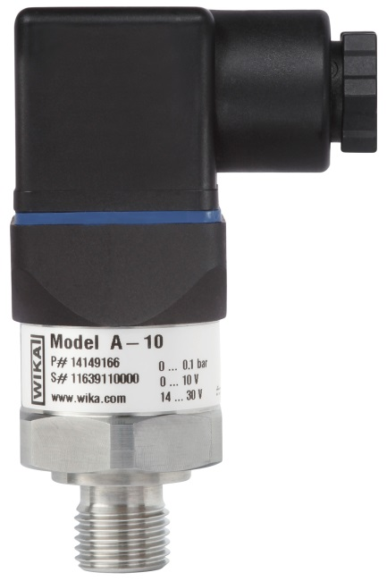

Edited by:
WIKA Alexander Wiegand SE & Co. KG
André Habel Nunes
Marketing Services
Alexander-Wiegand-Straße 30
63911 Klingenberg/Germany
Tel. +49 9372 132-8010
Fax +49 9372 132-8008010
andre.habel-nunes@wika.com
www.wika.de

WIKA press release 10/2016

