Installable anywhere: Slimline
pressure switch with IO-Link and display

Klingenberg, December 2019.- WIKA's new model PSD-4-ECO programmable pressure switch enables pressure monitoring in machines which is as uncomplicated as it is reliable. With IO-Link version 1.1, the instrument − in a space-saving design and with a two-colour display − is a flexible automation solution.

The plug-and-play principle enables the new pressure switch to be commissioned quickly, either through individual factory pre-configuration or via IO-Link. Its display can be set so that the operator receives on-site information without any prior knowledge about the status of the current pressure or the condition of the instrument. For example, a measured value within the defined pressure range is displayed in green, a measured value outside the limit in red. For the best possible view of the display, the case head can be rotated and the display tilted electronically through 180°.

The PSD-4-ECO has been designed for installation in tight spaces. With a diameter of only 29 mm and a vertical orientation of the electrical output, it can be fitted almost anywhere. The pressure switch is also suitable for harsh environments: It is designed for medium temperatures between -40 °C and +125 °C and shock resistant up to 50 g.

Number of characters: 1.013
Key word: PSD-4-ECO

Manufacturer:
WIKA Alexander Wiegand SE & Co. KG
Alexander-Wiegand-Straße 30
63911 Klingenberg/Germany
Tel. +49 9372 132-5049
Fax +49 9372 132-406
vertrieb@wika.com
www.wika.de

WIKA company photograph:
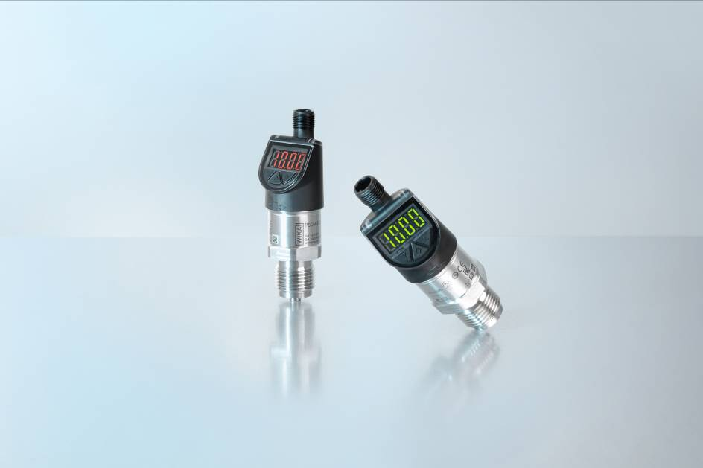
Pressure switch PSD-4-ECO

Edited by:
WIKA Alexander Wiegand SE & Co. KG
André Habel Nunes
Marketing Services
Alexander-Wiegand-Straße 30
63911 Klingenberg/Germany
Tel. +49 9372 132-8010
Fax +49 9372 132-8008010
andre.habel-nunes@wika.com
www.wika.de

WIKA press release

